# Main.java

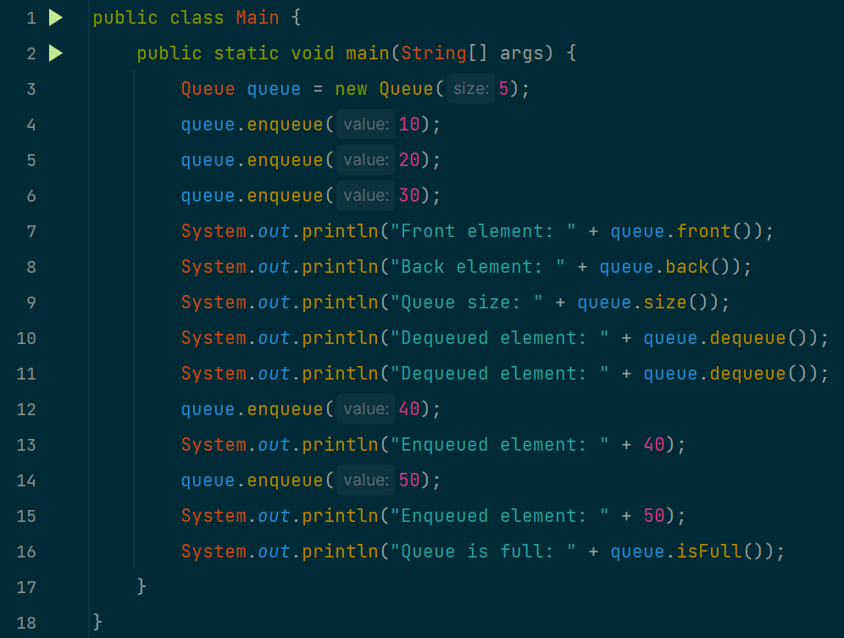

# Queue.java

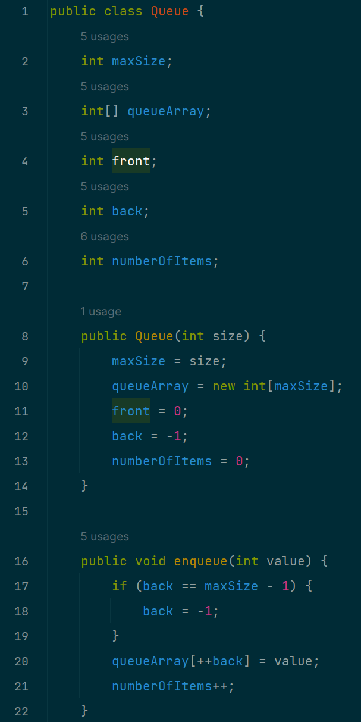

# OUTPUT

